BILKENT UNIVERSITY


MECHANICAL ENGINEERING DEPARTMENT

ME 232 –MECHANICS AND MATERIALS II
EXPERIMENT REPORT

HARDNESS TEST
Ahmet Nuri Kirişci
22003024 Section-1
Group: Day 3 Group 1(Metal)-Day 4 Group 1 (Polymer)

Submitted: 21.05.2023

Metals

- Steel_MEAN: 318.70, Copper_MEAN: 99.78, Aluminum_MEAN: 116.53
Steel_STDEV: 61.018, Copper_STDEV: 3.215, Aluminum_STDEV: 3.325

Comments: Variations in the measurements could arise because of possible errors. Errors occur firstly due to experimental procedure. The measurements for d1 and d2 values are calculated from the image of the indentation by selecting the borders of it by hand. In that part of the experiment, significant errors may occur due to such practice. Secondly, the surface quality of the material during the measurement can highly affect the results. Besides that the imperfections in the material could lead to different measurements for the different parts of the material since one cannot say the material is not 100% percent homogeneous. Also as the size of the indentation gets smaller, errors due to misreading increase as in the case of the steel specimen. While the indentation of copper and aluminum specimens is much bigger and clearer, the indentation of the steel specimen is much smaller.

Steel |  |  | Copper |  |  | Aluminum
d1 (µm) | d2 (µm) | HV | d1 (µm) | d2 (µm) | HV | d1 (µm) | d2 (µm) | HV
68.44 | 65.85 | 411.19 | 136.41 | 131.75 | 103.13 | 128.64 | 128.07 | 112.53

The code input and output are copied below for the calculation, for the equation used check the code at the appendix
“Input:
Enter d1: 136.41
Enter d2: 131.75
Output:
HV = 103.15146872027385”
Substituting the d1 and d2 values into the equation for HV gives the same result as the acquired data.

- For the HV value 411.19 from Day3-Group1 data for the steel specimen, “AISI 4820 Steel, heat treated, machined to 25 mm, pseudocarburized, reheated to 835°C, 150°C (300°F) temper (300°F)” might be employed for the test. (See Appendix )

- Using table 4.3 in Dowling, (Interpolation has been done for the untabulated values)
Steel_MEAN: 318.70 (HV) 302.22 (HB)
Steel_(Day3-Group1): 411.19 (HV) 388.62 (HB)
Applying relation for the ultimate stress it is calculated as for the mean value: 1042.66 MPa, and for the specific group data: 1340.74 MPa

For the guessed material ultimate stress is tabulated as 1322 MPa and the calculated value is 1340.74 MPa so the assumption is consistent with some error.

- For specific requirements one can desire a high-hardness or low-hardness material. While high-hardness materials are generally employed where the part made of the material must resist high loads, survive wear due to dynamic loads, such as gears, etc. low hardness materials are desired where ductility is required to be shapeable for manufacturing. Also, low hardness may be desired for the shock absorption to be durable to fracture.
In some cases, one may desire parts that have high hardness on the outside and low hardness on the side. Such a situation arises since it is cost-efficient to harden only the surface of the material. Also, it is easier to shape a low-hardness material, and then harden the surface of it to make it resistant to wear and loads.
There are different manufacturing techniques to achieve such material. For example, carburizing, nitriding, induction hardening, or flame hardening. Another common method for that is the case of hardening where the surfaces of low-carbon irons are fed with carbon atoms with heat, and carbon atoms form a hardened layer on the surface. Such a technique is generally employed for gears.

Polymers

- Mean Silicone: 12.91
STDev Silicone: 3.453
-------------------------------------------
Mean PDMS: 27.20
STDev PDMS: 1.947
-------------------------------------------
Mean MRE: 37.50
STDev MRE: 7.397

Comments: There are possible reasons for the deviation of the measurements, due to experimental procedure and material imperfection. During the experiment, the level of the indenter must be arranged a properly according to the thickness of the material, and at the moment of application of the force, the readings may change over time since the elastic polymer materials are used. Besides that for thin materials ground effect may alter the measurements. On the material side, the surface quality of the test specimens highly affects the measurement results regarding the point of measurement. Also, the homogeneity of the material affects the results since it is not 100% homogeneous. For example, the inhomogeneity of the material composition of the MRE material arises a high standard deviation value. One can also note that calculations are done under the assumption of infinite material surface which may not be the case for the measurements taken from the points closer to the edge.

Silicone Shore = 12.91 0.67 (MPa) Young’s Modulus (E) Values
PDMS Shore = 27.20 1.36 (MPa)
MRE Shore = 37.50 2.12 (MPa)
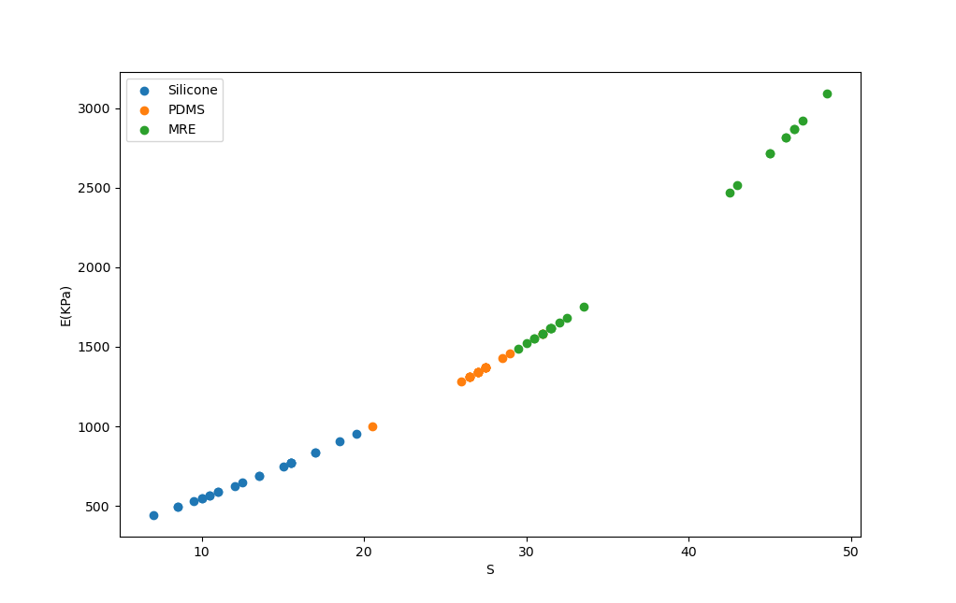
One can observe from the E vs S graph that shore hardness value and Young’s Modulus have an exponential relationship which means small changes in S leads to bigger changes in E values. This difference becomes even larger as the S values increase since the slope of the graph increases with increasing S values.

- Regarding the mean shore hardness values of the materials, they correspond to the soft rubber materials. 12.91 value corresponds to something like a soft mouse mat, 27.20 corresponds to a rubber band, and 37.50 corresponds to an eraser-like material. (See Appendix)

- First of all the aims of the two test procedures are different from each other, and so do their outcomes. While the Shore Hardness A test is designed to measure the surface hardness of the material Tensile Test is employed to determine materials’ response to the tensile loading.

Secondly, the scale of the experimental procedures affects the results. In the shore hardness test, a very tiny area is concerned with the assumption of a material with an infinite surface, which is not the case actually. On the other hand, in the tensile test much bigger materials are under concern. Because of its scale, the shore hardness test falls short to consider all the imperfections of the materials, but only in a tiny area. In contrast to that, the tensile test considers the imperfection, at least on a much bigger scale.

Lastly, the relation used in the shore hardness test to calculate young modulus have two drawbacks: Firstly the relation give always the s = 0 for materials with an E value less than E(0), secondly, it cannot determine very stiff materials since as S goes to 100 (upper limit) E becomes infinitely large, so equation does not work also at the upper bound.

- E(0) value calculated as 0.21 MPa, since this is the lowest bound of the test range polyurethane foam and gel-like materials are hard to determine through shore hardness A test.

References:
Dowling, Norman E., et al. Mechanical Behavior of Materials Engineering Methods for Deformation, Fracture, and Fatigue. 5th ed., Pearson, 2020.

Aisi 4820 Steel, Heat Treated, Machined to 25 Mm, Pseudocarburized, Reheated to 835°C, 150°C (300°F) Temper (300°F), www.matweb.com/search/DataSheet.aspx?MatGUID=79226bb7009f48cc803ff4b484fd043a. Accessed 21 May 2023.

“Metal Case Hardening: Surface Hardening Process: SST.” Specialty Steel Treating, www.sst.net/metal-case-hardening/. Accessed 21 May 2023.

Appendix:

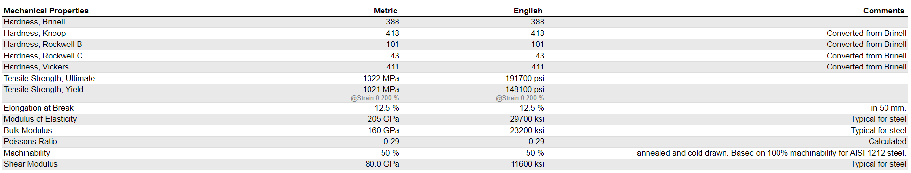
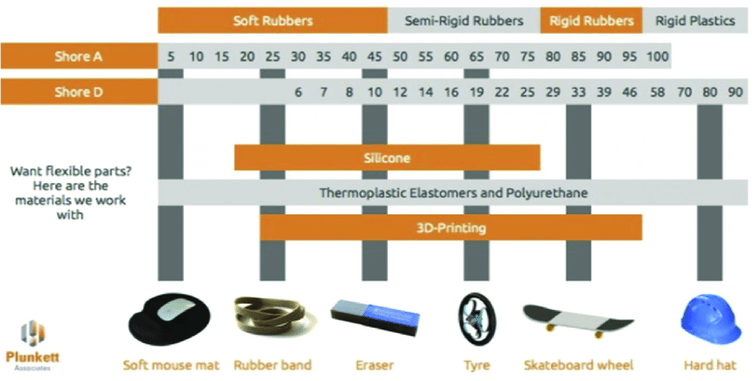

Code:
# -*- coding: utf-8 -*-
"""
Created on Sun May 14 22:43:28 2023

@author: Misafir
"""
# IMPORTING REQUIRED LIBRARIES------------------------------

import pandas as pd
import os
import statistics
import matplotlib.pyplot as plt
import math
#------------------------------------------------------------

#CONSTANT VARIABLES-----------------------------------------

S1 = "Steel"
S2 = "Copper"
S3 = "Aluminum"
#-----------------------------------------------------------

#DATA ACQUIRE------------------------------------------------

data = pd.read_excel("vickers.xlsx",sheet_name="Sheet1")

DataDic = {}

for col in range (4,11,3):
datas = []
for value in data.iloc[4:,col]:
if str(value) != "nan" and str(value) != "HV":
datas.append(float(value))
if col == 4:

DataDic[S1] = datas
elif col == 7:
DataDic[S2] = datas

else:
DataDic[S3] = datas

#print(DataDic)
#---------------------------------------------------------------

#MEAN AND STDEV CALCULATIN RESULTS------------------------------------
print("-----------METAL VICKERS/BRINELL-------------------")
for key in DataDic:

print(key+"MEAN:"+" "+str(statistics.mean(DataDic[key])))

print(key+"STDEV:"+" "+str(statistics.stdev(DataDic[key]))+"\n")

#-----------------------------------------------------------------------

#FORMULA CHECK FOR SECOND QUESTION--------------------------------------
"""
d1 = float(input("Enter d1: "))
d2 = float(input("Enter d2: "))

d12 = ((d1*10**(-3))+(d2*10**(-3)))/2

P = 1 # kgf

HV = (1.8544*P)/(d12)**2

print(HV)
"""
#------------------------------------------------------------------------
print("----POLYMER SHORE------------")
#POLYMER DATA ACQUIRE----------------------------------------------------
P1 = "Silicone"
P2 = "PDMS"
P3 = "MRE"

data_polymer = pd.read_excel("shore.xlsx",sheet_name="Sheet1")

DataDic_polymer = {}
for col in range(2,5):

datas_polymer = []

for value in data_polymer.iloc[4:,col]:

if str(value) != "nan":
datas_polymer.append(float(value))
if col == 2:
DataDic_polymer[P1] = datas_polymer
print(f"Mean {P1}: "+str(statistics.mean(datas_polymer)))
print(f"STDev {P1}: "+str(statistics.stdev(datas_polymer)))
print("-------------------------------------------")
elif col == 3:
DataDic_polymer[P2] = datas_polymer
print(f"Mean {P2}: "+str(statistics.mean(datas_polymer)))
print(f"STDev {P2}: "+str(statistics.stdev(datas_polymer)))
print("-------------------------------------------")
else:
DataDic_polymer[P3] = datas_polymer
print(f"Mean {P3}: "+str(statistics.mean(datas_polymer)))
print(f"STDev {P3}: "+str(statistics.stdev(datas_polymer)))
print("-------------------------------------------")

#print(DataDic_polymer)
#------------------------------------------------------------------------

# POLYMER SHORE DUROMETER CALCULATION------------------------------------

d= 0.79*10**(-3)
c1 = 0.549 #N
c2 = 0.07516 #N
c3 = 0.025*10**(-3)

alfa = 4*d*c3

Datadic_polyE = {}

for keys in DataDic_polymer:
evalues = []

for values in DataDic_polymer[keys]:

E = ((3/alfa)*((c1+c2*values)/(100-values)))*10**(-3)

evalues.append((E,values))

Datadic_polyE[keys] = evalues

print(Datadic_polyE)

fig, ax = plt.subplots()

# Plot the data from the dictionary
for key, values in Datadic_polyE.items():
x_values = [t[1] for t in values] # Extract x-values from tuples
y_values = [t[0] for t in values] # Extract y-values from tuples
ax.scatter(x_values, y_values, label=key)

# Add legend
ax.legend()
plt.ylabel('E(KPa)')
plt.xlabel('S')

# Show the plot
plt.show()

#------------------------------------------------------------------------
#-----------------------E(0) CALCULATIN--------------------------------Ğ
print()
print("-----------E(0) CALCULATION----------------")

d= 0.79*10**(-3)
c1 = 0.549 #N
c2 = 0.07516 #N
c3 = 0.025*10**(-3)

alfa = 4*d*c3

E = ((3/alfa)*((c1+c2*0)/(100-0)))*10**(-3)

print(E)

